An Introduction to GIS
Using QGIS (v. 2.6.1)

Author: Michael L. Treglia
Postdoctoral Research Associate
Department of Biological Science
The University of Tulsa
E-mail: mike-treglia@utulsa.edu

Updated 14 January 2015

Opening Notes

Open-source tools for research in ecology and evolutionary biology, among other fields, are constantly expanding. Herein, I provide a tutorial of QGIS (www.qgis.org), which is capable of almost any GIS operation I’ve ever needed, either on its own, or using the various plugins and associated tools. QGIS installs and directly links with other programs including SAGA GIS and GRASS GIS, allowing users to take advantage of cooperation among the free and open source software developers. Furthermore, data can be exported to a variety of formats, for use in other programs.
My goal here is to provide a basic skill-set to the new GIS/QGIS user, so they may navigating the software for their own work, and further explore its capabilities. This tutorial is by no-means comprehensive. I suggest users browse and search the QGIS documentation (http://qgis.org/en/docs/index.html) when they are stuck, or make use of relevant support channels (http://qgis.org/en/site/forusers/support.html).

Some brief acknowledgements: I am grateful to the QGIS community for constant development and support of the software. I also thank Dr. Michelle Lawing in the Department of Ecosystem Science and Management at Texas A&M University (TAMU) for getting me involved in, and organizing a workshop at for which this material was first developed. Additionally, Dr. Toby Hibbitts, curator reptiles and amphibians at the of the Biodiversity Research and Teaching Collections at TAMU provided data for copperhead specimens, used herein as a text-delimited data source.

Table of Contents
Opening Notes 1
Table of Contents 2
Installing QGIS 4
Installing Plugins 5
Data Sources Used in this Tutorial 6
Get to Know QGIS 7
Open Shapefiles 8
Open Delimited Text Layer (e.g., points based on a table with Coordinates) 9
Add a Background Layer 10
Open and Manipulate a Raster Layer 12
Projections 14
Projection of Layers and Project 14
Changing Projections (CRS) 15
Changing Project CRS 15
Changing Vector CRS (for a Shapefile) 16
Changing Raster CRS 17
Geo-Processing of Data Layers and Associated Tables 19
Some Basic Vector Operations 19
Clipping 19
Difference Clip (Clip out the inner area of a polygon) 20
View and Edit the Attribute Table 22
Spatial Join 23
Add Geometry Information to Attribute Tables 26
Some Basic Raster Operations 28
Calculate Slope from a DEM 28
Reclassify Raster 30
Raster Calculator 34
Using Vector and Raster Datasets Together 36
Clipping a Raster 36
Compute Zonal Statistics for Polygons 38
Making a Quality Map 41
Setting up for a Map 41
Putting Everything Together 44
Adding the Map of interest to the Layout 44
Adding Gridlines and Coordinates 44
Adding Scale Bar, North Arrow, and Legend 46
Adding an Inset 49
Final Formatting and Exporting the Map 50
Exporting the Map 50
Closing Comments 52

Installing QGIS
I generally recommend working with the most recent version of QGIS available (the current version at the time of writing is 2.6.1). Either the 32 bit or 64 bit version should work (everything presented herein was tested using QGIS 2.6.1, 64 bit, on Windows 7).

Note: The installation files can be somewhat large (a few hundred megabytes for Windows versions) and might take some time to download and install.

For Windows users:
Download and run the standalone installer, available here: http://qgis.org/en/site/forusers/download.html (QGIS Standalone Installer Version 2.6.1)
- When it gives you the option, you do not need to download the sample datasets, although feel free to and use them for other tutorials or examples.

For Mac OS users:
OS 10.7 and Higher: Follow the installation instructions provided here: http://www.kyngchaos.com/software/qgis
OS 10.6.8: Try using the latest experimental build for Mac OS 10.6.8 provided here: http://qgis.dakotacarto.com/ (scroll down to and click on “Nightly for Snow Leopard - Mac OS X 10.6”).
Alternatively, try compiling with HomeBrew (http://brew.sh/), following instructions here: https://github.com/OSGeo/homebrew-osgeo4mac.

For Linux Users:
Follow instructions provided here: http://qgis.org/en/site/forusers/alldownloads.html#linux.

Installing Plugins
One of the strengths of QGIS is the availability of capable plugins that have been written for it.
- To see what plugins are installed, open QGIS by double-clicking on the “QGIS Desktop” icon on your desktop or in your start menu.
- Then, click the Plugins menu at the top of the main QGIS window, and navigate to “Manage and Install Plugins”.
- When the Plugins window opens, search for the following plugins and install them if they are not indicated as already installed (having an X to the left of the name):
  - OpenLayers Plugin
  - Table Manager
  - Zonal Statistics Plugin
  - Processing

Data Sources Used in this Tutorial
The data sources used in this tutorial are available for download in a single .zip folder, at the URL where you accessed this document. Individual data layers and original sources are listed below. Please see the URLs for the original sources or the included metadata for individual layers for more detail. Throughout the document, I primarily refer to layers with the italicized names given below.

Text Delimited Table
- Copperhead Data – “Brazos County A contortrix_TxCentral.csv” – Specimen locations for copperheads, Agkistrodon contortrix, in Brazos County, Texas, provided by the Biodiversity Research and Teaching Collections at Texas A&M University (http://brtc.tamu.edu/). Most localities were collected in the WGS84 datum; the others are assumed to be, for this tutorial.

Vector Data (Shapefiles)
The following layers for Brazos County and the city of College Station, TX were accessed from the City of College Station GIS Department (http://www.cstx.gov/index.aspx?page=3683).
1) County Boundary – Brazos_County_Boundary_8-20-02.shp (in /Brazos Limit Package”)
2) City Limits – City_Limits.shp (in /City_Limit_Package)
3) Rivers and Streams – Rivers_and_Streams.shp (in: /Rivers and Streams Package”)

Raster Data
The raster dataset used in this tutorial is the 1 Arc-second (~30m) Digital Elevation Model from the U.S. Geological Survey
- DEM – imgn31w097_1.img (in /DEM 1ArcSec)

Get to Know QGIS
Open QGIS on your computer using the QGIS Desktop icon in your Start Menu or Desktop.
- Close the tip of the day – you can permanently disable or scroll through them.
- Only one pane is open – the “Layers” pane on the left side
- Explore icons by hovering over them with the mouse; click on menu-bar items to explore the drop-down menus.
To save the project click the “Save” icon and designate a file location. When you re-open a project, any layers that you were using should be in the same locations on your computer; if they are not, you will need to re-designate the appropriate file paths. If you transfer data and a project file to another computer, keep the files in the same locations relative to one another and the project should open without a problem. Make sure to periodically save the project as you work.

Before we get started, we will set the software to “Project on the Fly”. This is described in more detail in the section on Projections, but in brief, it allows layers in different projections to be displayed in a common coordinate system. Click on the “Project”menu from the menu bar at top, and select “Project Properties”. In the window that appears, select the “CRS” tab, check the box next to “Enable ‘on the fly’ CRS transformation” and click the “OK” button.

Open Shapefiles
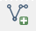
- Click the “Add Vector Layer” icon (Or use “Layer” menu and navigate to “Add Vector Layer”)
  - Set the Source Type to “File” and Encoding to “System”
  - Click “Browse” and navigate to the appropriate files, using the appropriate file types (for Shapefiles, set to “ESRI Shapefiles [OGR] (*.shp)”).
  - Open County Boundary, City Limits, and Rivers and Stream layers.
**Note –To access data from ESRI Geodatabase (.gdb files), set “Source Type” to “Directory”, and navigate to the .gdb file.
- Adjust the layer order by clicking and dragging layers up and down in the “Layers” pane.
  - Put Rivers and Streams on top, then City Limits, and County Boundary
- To adjust layer symbology (how the data appear):
  - Right click on individual layers and select “Properties” (or Double Click on the layer)
  - Select “Style” on the left; click on a symbol in the “Symbol Layers” box, and customize to your liking.
- To view the tabular data, right click on the layer and select “Open Attribute Table”.
- To view information about a layer at a specific point in space, click on the “Identify Features” icon on the tool bar, and click on the point of interest. The default setting show information about the layer highlighted in the “Layers” pane.

Open Delimited Text Layer (e.g., points based on a table with Coordinates)
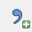
- Click “Add Delimited Text Layer” icon. (See example dialogue box on next page.)
  - Navigate to the appropriate file (Copperhead Data; “Brazos County_A contortrix.csv”) and set appropriate text delimiter (comma for this file).
  - If the first line contains field names (column names) make sure the “First record has field names” box is checked
  - Set the geometry definition (typically “Point Coordinates”), and identify fields for X and Y coordinates (e.g., Longitude and Latitude, respectively).
  - If the data are based on a geographic projection Decimal Degrees are expected; if data are as Degrees Minutes Seconds, check the “DMS Coordinates” box
  - Click “OK” and layer will appear in “Layers” pane. You can adjust the symbology by editing the properties as described above.

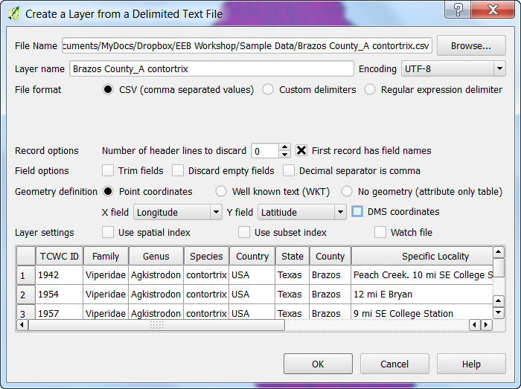
Add a Background Layer
When we import spatial data, we often like to visualize them over some sort of background layer, such as aerial imagery, or a simple map. This allows us to identify if layers are being displayed in approximately the right location, and it can help with some preliminary interpretation of data. For this exercise, we will utilize the OpenLayers plugin.
- Click on “Web” from the menu bar at top, navigate “OpenLayers Plugin”, and then to the layer type of your choice (lets go with the Google Maps “Google Hybrid” layer for now), and it will appear as the top layer on your map.
- Adjust the layer order and symbology so you can better visualize what is going on. The image below (right), illustrates the scene with this background layer and the county boundary.
  - If you look at the project properties, you should see that the project projection has changed to “WGS 84 / Pseudo Mercator” – this corresponds to what is used in these server-based data.
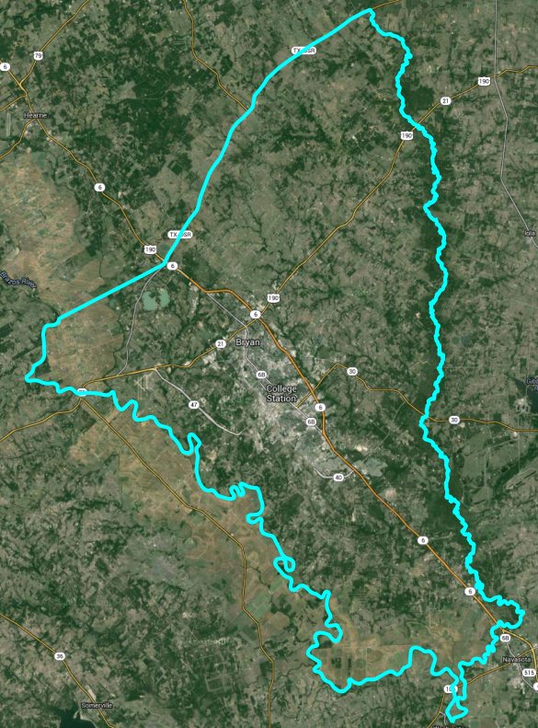
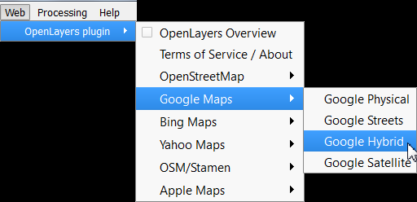

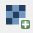
Open and Manipulate a Raster Layer
- Click the “Add Raster Layer” icon
  - Navigate to the desired file; can either specify desired file type or browse any of the available types. Browse to the “DEM 1ArcSec” folder and select “imgn31w097_1.img”.
- Change Color Palette
  - Right-click on the layer (“imgn31w097_1”) and select “Properties”
  - Click “Style” – There are lots of options to adjust. The below steps just serve as an example. (See next page for sample dialogue box).
    - Change “Render Type” to “Singleband pseudocolor” (Avoid multi-band options unless you are using multi-band imagery like Landsat data)
    - Adjust the Min/Max settings as desired.
      - Using the true “Min/Max” (second option) will have the color gradient span the entire range of values in the raster dataset.
    - Select a color ramp that you like (e.g., BrBG) and click “Classify” button to set bins automatically, and click “Apply”. If you like it, click “OK”, if not, adjust as needed. Feel free to try adjusting other options too.
      - You can also adjust colors and labels in the editing box to the left.
      - You can use “Save Style” and “Load Style” buttons to use a standard color ramp across multiple projects or raster layers.
- You can use the “Zoom In” tool to zoom in enough to see individual pixels. Select the tool from the toolbar, and click and drag a box on the area you wish to zoom to.
- To measure an individual pixel and make sure it is the size you expect click on the “Measure” tool from the toolbar, and select “Measure Line” from the drop-down menu.
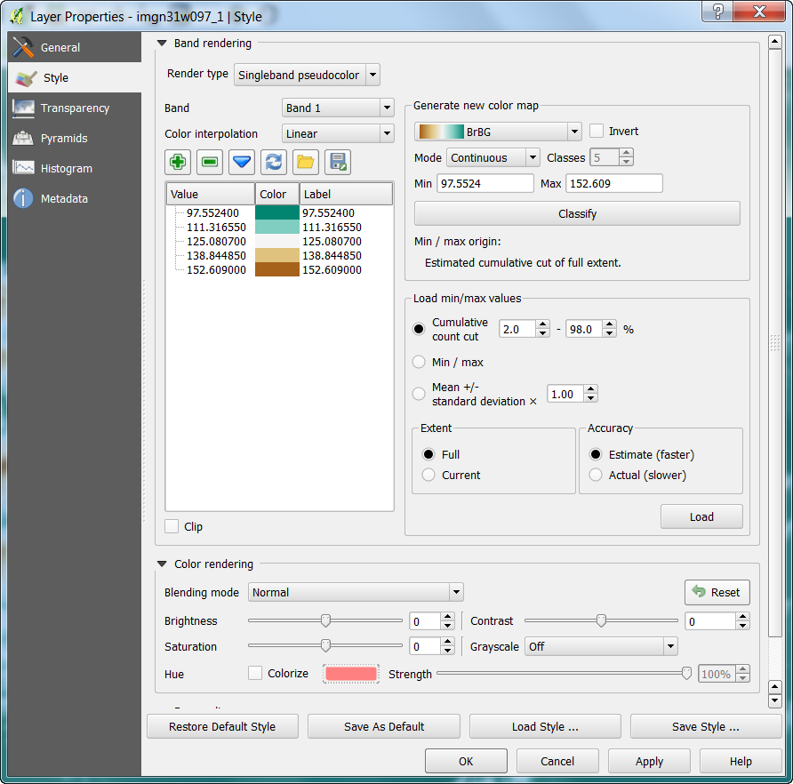
  - Click at one edge of the pixel, and drag the cursor to the other side; the dialogue box will show the measurement based on the units and datum of the Project CRS (see Projection Section, next).

Projections

Projection of Layers and Project
QGIS automatically reads projection information (i.e., the Coordinate Reference System [CRS]), if available, from respective layer files. For shapefiles, it relies on the “.prj” file; for raster data, it is often embedded in the file. If you load data without built-in projection information (e.g., a Delimited Text File), it assumes a geographic coordinate system (Lat/Long), and uses the World Geodetic Survey 1984 (WGS84) datum. It is always a good idea to check that the projection information is interpreted correctly by QGIS.
- To check the CRS, (and set it if it was not automatically detected) right-click on layer and select “Set Layer CRS”.
  - If you do this for the Copperhead Data you will see the CRS that selected is WGS84 (using Lat/Long coordinates). This is correct – the datum of the original data was exactly that, so nothing needs to be changed, although if it was incorrect, you could fix that here.
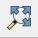
Earlier we set QGIS such that layers with different projections are “Projected on the Fly” for visualization – they are automatically transformed to be in the same coordinate space. Changing that, which will make it is easy to tell if individual layers are set to drastically different CRS. Click the Project Menu at on the menu bar at top and select Project Properties (or press CTRL+SHIFT+P). Then, uncheck the box at top for “Enable ‘on the fly’ CRS transformation” and click “OK”. Now you can see how the layers line up to each other when using their native projections – click the “Zoom Full” button on the toolbar at top, and the map area will zoom out to include all layers.

Changing Projections (CRS)
For many operations it is necessary to have all layers in the same CRS; even if it is not necessary, it can help speed-up processing considerably. The DEM has elevation in meters, according the layer’s metadata, and it is in a geographic projection. However, for computing some derivatives of elevation such as Slope, it is helpful to have the horizontal units the same as the units for elevation. Thus, we will work in a projection that is also defined in meters, the Albers Equal Area Projection. This projection may cause some distortion in shape, but maintains accurate area measurements. This is just a demonstration, and in doing your own work, it is important to consider how spatial distortions may manifest in different projections.
The steps for converting the CRS of raster and vector layers are somewhat different. Furthermore, when converting the CRS of raster layers, it is important to think about how resampling may cause distortion and inaccuracy. This will not be covered in depth here, but Mike Bostock provides a useful visualization of this: http://bost.ocks.org/mike/example/.

Changing Project CRS
As aforementioned, we will use the Albers Equal Area Projection, useful for dealing with the DEM. Other projections, such as Universal Transverse Mercator could also be used.
- Navigate to the Project Properties dialogue box.
  - Browse for “North_America_Albers_Equal_Area_Conic” or use the Filter box to search for that, and select the appropriate CRS. A standard code used for this CRS (the EPSG code) is 102008.
- Alternatively, right-click on a layer with the desired CRS, and select “Set Project CRS from Layer” [not applicable for this project].

Changing Vector CRS (for a Shapefile)
This process involves creating a new shapefile with the desired CRS.
- Right-click on layer that you wish to change the CRS of (in this case, select the Copperhead Data) and Select “Save As”
- Set “Format” to “ESRI Shapefile”
- Use the “Save As” box to designate an appropriate file location and name for the resulting shapefile.
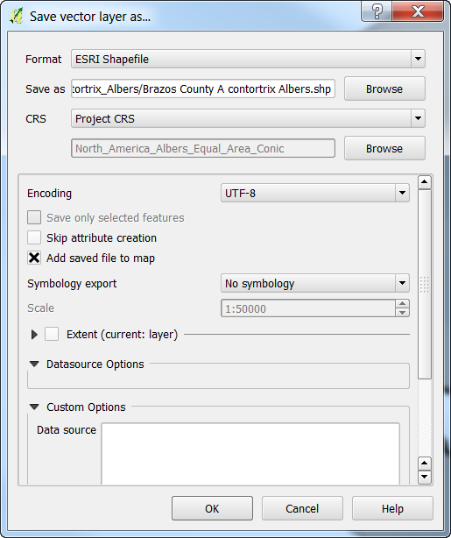
- For the CRS, you can use the “Project CRS” (Or use the Browse button to navigate to the appropriate CRS if necessary).
  - Selecting “Layer CRS” retains the original CRS
- Check the box for “Add Saved File to Map”
- Click “OK” (the original layer can then be removed from the map by right clicking on it and selecting “remove).
- Now do this for the remaining shapefiles.

Changing Raster CRS
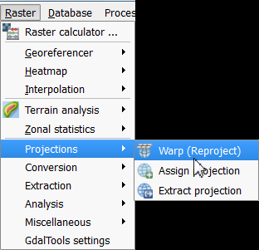
As with vector datasets, when reprojecting a raster, a new file is created and added to the project
- Click on the Raster menu, mouse along to Projections, and click on “Warp (Reproject)”.
In the Dialogue box (illustrated on the next page):
- Designate the input file from the current project
- Set an output file and the Source SRS (same as CRS).
- Set the Target SRS to the desired CRS.
- Select the desired resampling method.
  - For continuous variables, typically want to use something like bilinear or cubic spline that interpolates. If it is a categorical variable, nearest neighbor (“Near”) is generally appropriate.
- If using a computer with a multi-core processor, check the box for “Use multithreaded warping implementation”
- Check the box for “Load into canvas when finished” to bring the final product into the current project.
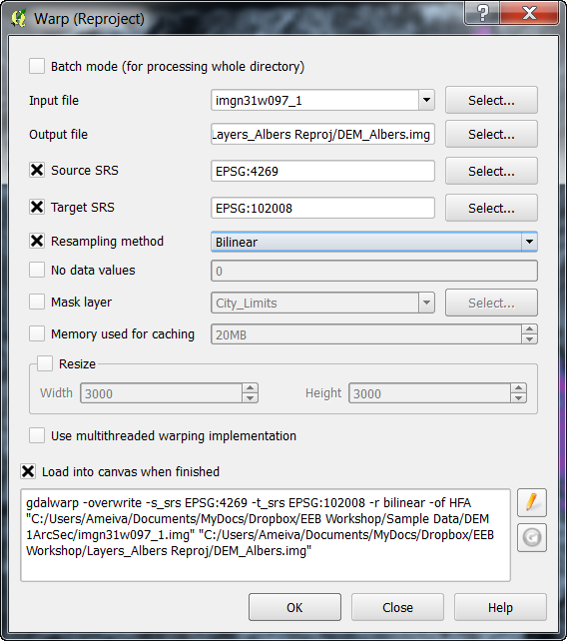
**Note – specific parameters for the reprojection of rasters can also be edited using the text at the bottom of the dialogue box, based on the arguments described here: http://www.gdal.org/gdalwarp.html. To start editing this section, simply click the pencil icon, place the cursor in the box, and start typing.

Geo-Processing of Data Layers and Associated Tables
QGIS has a wide variety of built-in processing operations, and with the other included programs it has incredible capability and functionality, easily accessible via the Processing Toolbox. We will only cover a handful of operations here, but I suggest exploring menus, the Processing Toolbox, and plugins to find other operations that you need. In QGIS, these operations generally create a new layer rather than simply editing the original.

Some Basic Vector Operations

Clipping (Remove unwanted sections of a layer, based on outlines of other Layer)
Hypothetically, say we are working on a project that involves streams of the city of College Station, but the stream layer that we downloaded was for the entire county. Thus, we will clip the Rivers and Streams to the County Boundary.
- Select the Vector menu at the top and navigate to “Geoprocessing Tools” and then “Clip” (illustrated on the next page)
  - Input Vector Layer is the layer that you want altered (Rivers and Streams).
  - Clip Layer is the Layer that you are clipping data to (City Limits).
  - Designate the new file you want to create in the Output Shapefile box
(“CS Rivers.shp”).
  - Check the box for “Add result to canvas” and click “OK”.
- Upon completion, view result and delete original if it is no-longer needed.
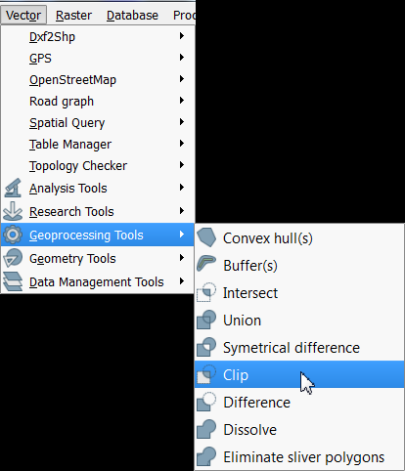
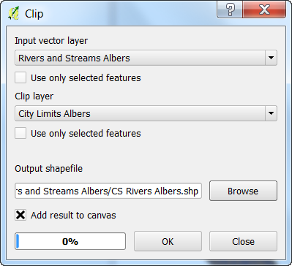

Difference Clip (Clip out the inner area of a polygon)
In another scenario, we may be interested in a geographic area, excluding a core area. With the data at hand, perhaps we are interested in something about County Boundary, but wish to exclude the area of College Station.
- Select the Vector menu at the top and navigate to “Geoprocessing Tools” and then “Difference” (from the same menu shown on the previous page).
  - Input Vector Layer is the layer that you want altered (Brazos County Boundary).
  - Clip Layer is the layer subtracting from the Input Vector Layer (City Limits).
  - Designate the new file you want to create in the Output Shapefile box
(“Brazos Cty No CS.shp”).
  - Check the box for “Add result to canvas” and click “OK”.
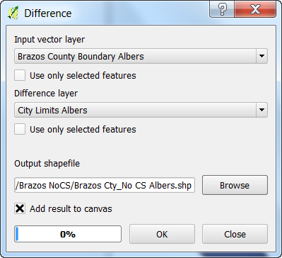
- Upon completion, inspect the result and delete original if it is no-longer needed.

View and Edit the Attribute Table
Many times we need to look at the attribute table for a given layer, and sometimes even make some edits.
- To view the attribute table, simply right click on the desired layer and select “Open Attribute Table”. Let’s start with the attribute table for the Rivers and Streams layer.
There’s lots of information here that came with the layer. Some things that might be of interest for researchers include the Name and the HydroType (what type of stream/river each element is).

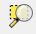
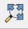
If you want to look at a single data entry simply select that row by clicking on the number to the left of the data, and it will become highlighted on the map. For the stream segments, they’re small, so you’ll need to zoom in to see it. While looking at the map, select the Rivers and Streams layer by clicking on it in the Layers pane, and then use the “Zoom to Selection” icon to focus on the selected stream segment. To zoom out to the entire map again, use the “Zoom Full” icon, or click the “Zoom Out” icon and click on the map.

To edit the table, you must first enable editing by clicking the “Toggle Editing Mode” icon in the toolbar above the table. Then you can edit text, and add/delete rows or columns using the icons at the top of the window. You can also do some table manipulations by altering the layer properties. You cannot, however, alter existing column names or data types from this menu. To do that, it is best to use the Table Manager plugin. If it is installed, click the icon, typically located on the left, along the “Layers” pane.

Spatial Join
We can use the spatial relationships among objects in our project to join tables with different information.

Let’s add the name of the county that streams are located in as a field for the Rivers and Streams layer. We will use the Rivers and Streams and the County Boundary layers in this example.
- We need to make sure the attribute table for County Boundary has a field with the county name, preferably with a field name that is unique among both layers.
  - Open the attribute table for County Boundary; there is a field with the county name (“Name”). We could use this column as-is for the join, but Rivers and Streams already has a column called “Name”. To avoid confusion, we will re-name the column
    - Close the attribute table, make sure County Boundary is selected in the Layers pane, and open the Table Manager.
    - Highlight the field “Name”, click the “Rename” button, and change the name to something logical (e.g., CountyName). Click the “Save” button, and close the window.

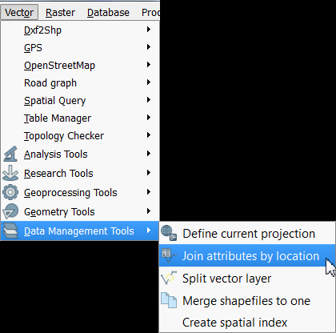
With the attribute tables set up appropriately, we can do the now do the join.
Use the Vector menu to access “Data Management Tools”, and then click “Join attributes by location”. (Dialogue box on the next page).
- The “Target Vector Layer” will be the layer we wish to add information to (Rivers and Streams)
- The “Join Vector Layer” will be the layer we wish to add information from (Brazos County Boundary)
- For this example, use the default options for “Attribute Summary” and “Output Table”, and set a the information for the resulting shapefile.
- Click “OK” and select “Yes” when a window pops up asking if you want to add the new layer to the project.
- If you open the attribute table for the new stream layer, you will see all of the information from County Boundary associated with the streams.

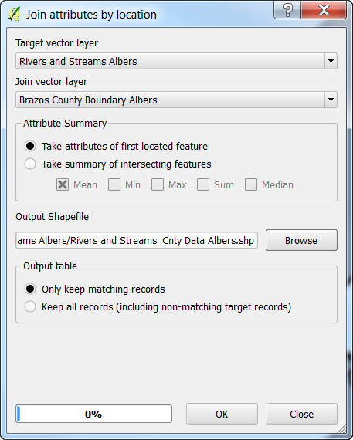

Add Geometry Information to Attribute Tables
Vector datasets will sometimes come with geometry information about the layer in the attribute tables (e.g., length of lines, or perimeter and area of polygons). This is useful, although if you transform the data to a different projection, the geometry may no longer be accuate because the alternative projection is a somewhat different representation of Earth’s surface. Other times, individual layers do not contain any geometry information that might be desirable.

Most of the vector layers we are using already have geometry data. For this exercise, we will first remove the geometry column for the Rivers and Streams layer and then use QGIS to add geometry information back in.
- Click on the Rivers and Streams layer in the “Layers” pane to select it.
- Open the Table Manager.
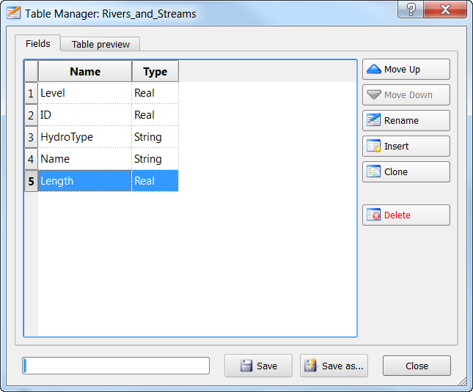
  - Select the “Length” field and click the “Delete” button to delete it.
Click “Save” and close the window.
- If you want, open the Attribute Table for the layer to confirm the field was deleted. Close it before the next step.
- Use the Vector menu to navigate to “Geometry Tools” and “Export/Add geometry columns.
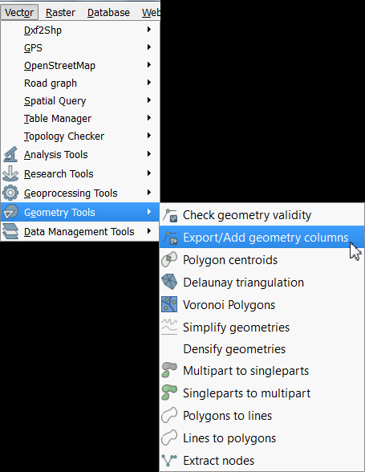
- Select the Rivers and Streams layer, use “Calculate using” = “Layer CRS” (for the current projection of the layer) and click “OK”.
  - After the processing bar completes, close the window.
- Open the attribute table for Rivers and Streams and you should now see a new column, “LENGTH”.

Some Basic Raster Operations
Both stand-alone and with plugins, QGIS has a diverse toolkit for working with raster datasets. Only a handful are covered here, but I encourage readers to browse menus, plug-ins, and documentation to find other operations you may need. Note that there are also various image processing tools that are useful for remote sensing work.

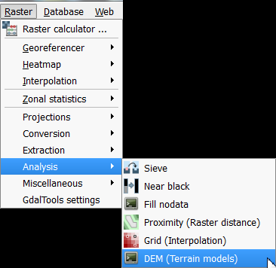
Calculate Slope from a DEM
- Use the Raster menu to navigate to “Analysis” and then “DEM (Terrain models)”
- In the Dialogue box, select the Input File (DEM Albers), and designate an output file (note: you will have to designate a file type; here I use ERDAS Imagine format (.img), but you can use others as well; be sure to include the file extension in the file name).
- Set the “Mode” to “Slope”. There are a number of other processing options you can choose if you wish.
- Change any of the “Mode Options” if you wish, though I will just use the default settings; make sure the “Load into canvas when finished” box is checked.
- Click “OK”.
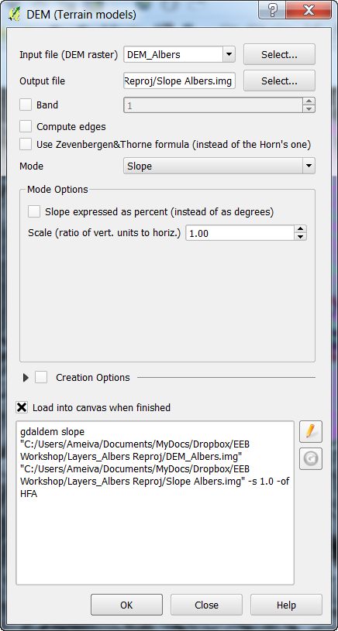
*Note – As with the reprojection of rasters, the terrain model options can also be adjusted with the set of commands at the bottom following the arguments listed here: http://www.gdal.org/gdaldem.html. To enable editing, click the pencil icon, illustrated to the left.

Reclassify Raster
Many times we need to reclassify values from a raster dataset. In this example, we will change continuous data into categorical groups; this may be appropriate if we know specific tolerances of a species, and have a relevant raster layer. I find the easiest ways to reclassify a dataset are using either the GRASS or SAGA GIS utilities, accessed through the Processing Toolbox. Here, we’ll use SAGA GIS (www.saga-gis.org/).
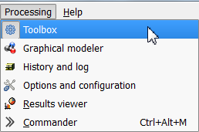
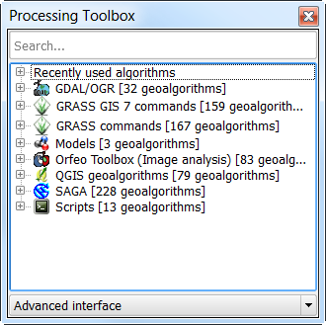
- Open the Processing Toolbox - click the Processing menu, on the menu bar at top, and select “Toolbox”.

- You should now see the “Processing Toolbox” (above, left). Make sure the option at the bottom is set to “Advanced Interface”, not “Simplified Interface”. This toolbox allows you to access algorithms and functions from a variety of other programs that were installed with QGIS including GRASS and SAGA.
We will reclassify values of the DEM (elevation) to indicate that pixels are suitable for a hypothetical species (>75 m; set to 1), or not suitable (≤ 75 m; set to 0).
Expand the list under SAGA by clicking on the “+” next to it, then expand the list under “Grid - Tools”, and double-click on “Reclassify grid values”.
- Select the DEM Albers layer as the Grid layer, and change the “Method” to “[2] simple table”
- Scroll down to “Lookup Table” and click on the “…” icon.
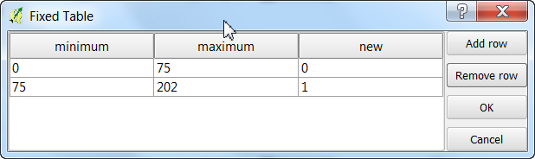
- Fill in the table as indicated below, then put your cursor in the third column and click “Remove row”, and then “OK”. The lowest and highest values (0 and 150) are based on the maximum and minimum of the entire DEM, which can be viewed by clicking the “+” next to the layer in the “Layers” pane.
- Leave the “operator (for table)” option set to the default
- Make sure the box is checked for “Open output file after running algorithm”
- Set the “Reclassified Grid” to a file of your choice (for this, geoTIFF [.tif] seems to work well; .img does not for some reason, as it has multiple bands in the output).
- Click “Run”; you will see a new layer “Reclassified Grid” in the “Layers Pane” – right click on it and select “Rename” to rename it appropriately (e.g., DEM Reclass)
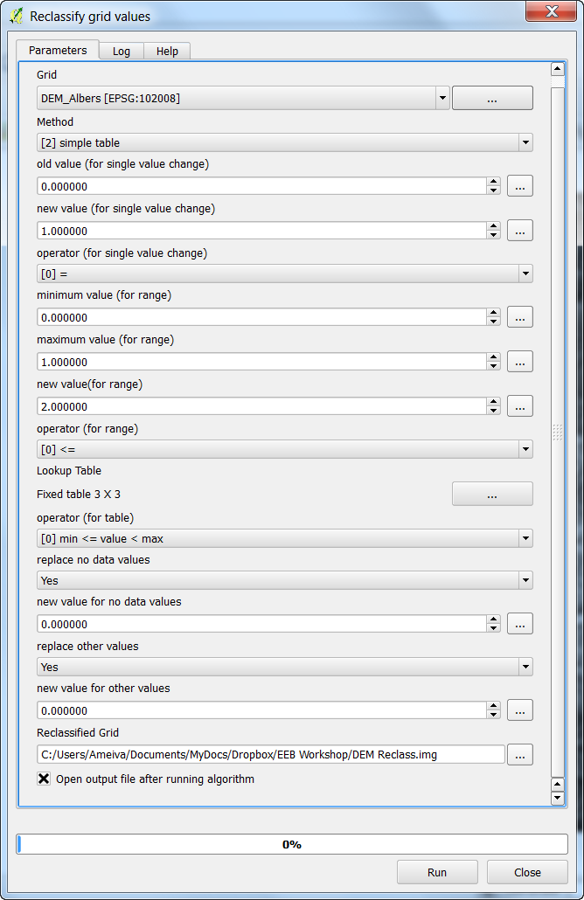
*Note, there are a variety of options here; those used here accomplish the task at hand; I encourage you to explore SAGA GIS, and explore what other options do in your free time.

We will now do the same thing for the Slope raster using, following the values in the lookup table below. (Low slope, 0-2° are suitable for the hypothetical species; high slopes, >2°, are not). Rename this new layer appropriately (e.g., Slope Reclass)
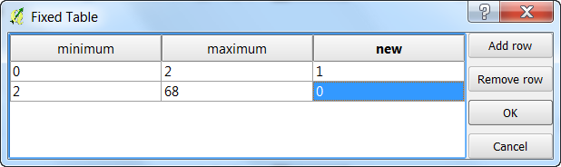
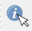
To verify that these reclassified layers are correct, you can bring the respective reclassified layer to the top, and use the “Identify Features” tool to inspect the values of each raster. Click on the icon in the toolbar, and a new pane should appear (typically on the lower left, “Identify Results”). Then click the mouse on a point, and it will by default show you the properties (e.g., value or fields) of the layer highlighted in the “Layers” pane. You can adjust the “Mode” and “View” options in the pane, to view characteristics of multiple layers at once.
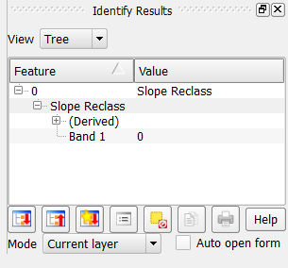

Raster Calculator
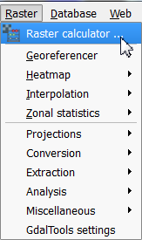
Many times we need create a new raster layer that is based on a composite of other layers. For example, in the previous examples we reclassified DEM Albers and Slope Albers rasters to identify where elevation and slope are suitable for a hypothetical species. We can combine these reclassified layers, mathematically, to identify where BOTH elevation and slope are suitable, simply by multiplying overlapping pixels from the respective layers. In this resulting raster, areas where a pixel is 0 in either raster will be 0 (unsuitable based on both layers); locations where both characteristics are suitable will be represented by values of 1.
- Use the Raster menu on the menu bar and navigate to “Raster Calculator”.
- In the dialogue box that pops up, double-click either the DEM Reclass or the Slope Reclass layer to add it to the expression box in the bottom. (See next page for an example dialogue box.)
- Click the “*” button to designate the multiply function.
- Add the other relevant layer to the expression box
- Designate an output location, set the format, check “Add result to project”, and click “OK”.
After processing, you will see the new layer in the “Layers” pane, and you can explore it to ensure the output is as-expected.
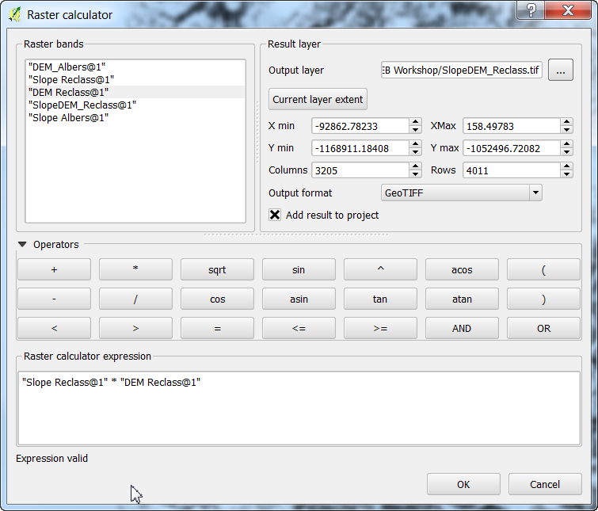
You can use this tool for various other calculations, using the buttons provided. You can also type in the “Raster calculator expression” box at the bottom, to add numeric terms and such.

Using Vector and Raster Datasets Together

Clipping a Raster
When downloading raster layers, they are frequently available for larger areas than necessary, which can contribute to additional processing time and decrease available memory. To deal with this, we can easily clip the raster to the bounds of a vector dataset or to a set of boundaries based on coordinates.
- Click on the Raster menu from the menu bar, navigate to “Extraction” and click on “Clipper” to open the relevant dialogue box (shown on the next page).
- Designate a raster as the input file (I will use “SlopeDEM_Reclass”, the result of the previous raster calculation, or the habitat suitability map for a hypothetical species).
- Check the box for “No data value” and set it to something not in your current raster layer. We’ll use -9999, which is commonly used for this purpose.
- For “Clipping Mode”, click in the circle for “Mask layer” and select a vector layer that you want to use for the boundaries of the new raster layer. We’ll use the City Limits in this exercise. If you wish, you can also use the “Extent” option and designate the appropriate bounding coordinates.
- Make sure the box is checked for “Load into canvas when finished” and click “OK”
The new layer will appear in the Layers pane and you can inspect as needed.
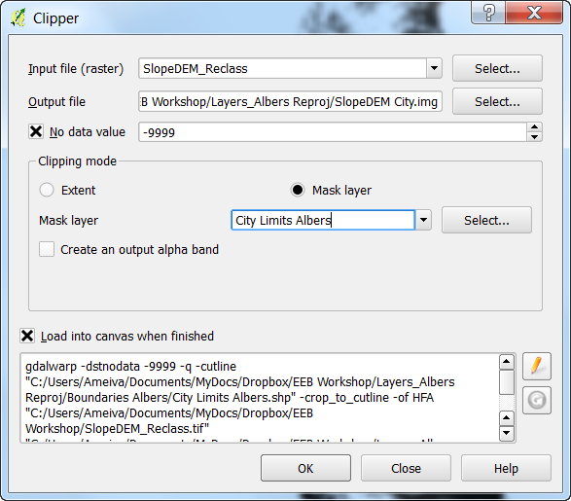
* This operation is effectively done using the same basic commands as for reprojection of rasters, and similarly, the parameters can be edited in the text box at the bottom based on the “gdalwarp” function.
** To fit the raster in the appropriate space as designated by the vector layer, it actually resamples the raster data and moves it slightly to fit. You can use the arguments in the gdalwarp command to select the desired resampling type.

Compute Zonal Statistics for Polygons
It is often useful to calculate metrics from a raster layer for a vector dataset, for example the mean elevation or slope of a polygon. The “Zonal Statistics” plugin is great for this, and there are other tools (e.g., in SAGA GIS) that allow additional flexibility.
Using the Zonal Statistics plugin:
- Use the Raster menu from the menu bar to navigate to and click on “Zonal statistics”
- For “Raster layer”, select the raster that you want to compute statistics from; for the “Polygon layer containing the zones”, select the appropriate vector layer. We’ll use the DEM and the County Boundary layers, respectively
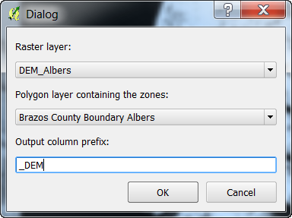
- Designate an prefix for the resulting columns (to help remember which raster you used) and click “OK”
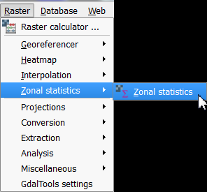
You can view the result by opening the attribute table for the polygon layer; and you will see new columns representing the “count” (count of all contained pixels”, the “sum” (sum of all values for the contained pixels), and the “mean” (average of all values for the contained pixels).
Using SAGA GIS:
- In the “Processing Toolbox” expand the menu for “SAGA”, then expand “Shapes – Grid” and double-click on “Grid statistics for polygons”. Note there are a number of other useful options, like adding grid values to points or other shapes.
- In the dialogue box (next page), under “Grids” click the “…” button to and select the desired raster (we’ll use the DEM again).
- Under “Polygons” select the vector layer you wish to calculate the raster statistics for. Again, we’ll use the County Boundary.
- Select whichever statistics you wish to calculate. Note there are a number of options. We’ll use “Mean” and “Variance” (for the others, change the box below the titles to “No”.
  - You can designate quartiles you wish to calculate; if you want the Median, calculate the 50th quantile.
- In the “Statistics” box, you can let it save the output to a temporary file, which will add new columns to the existing table and create a new layer for it called “Statistics”.
- Check the box for “Open output file after running algorithm” and click “Run”
- You can then view the results in the attribute table. In QGIS the columns are not named with the statistic, but with an abbreviation of the raster and a sequential number; you can use the table manager to rename these appropriately.”
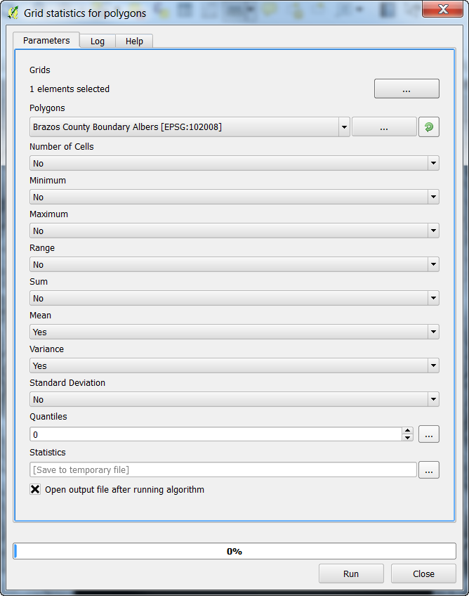

Making a Quality Map
QGIS works well for making maps, with easily customizable symbology, and a good set of tools to develop a layout for print and publication. Here, we will make a basic map of the habitat suitability raster for the city of College Station, with an inset showing where College Station is in Brazos County. We will include standard map elements including a scale bar, north arrow, legend, and coordinate grid. I encourage you to explore other options and setups for this after the workshop, or try making one with your own data. As with the other features of QGIS, I only have time to highlight a relatively small subset of map-making tools.
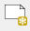
- To get started, open the print composer by clicking on icon indicated at left. If you were to have an existing layout that you wish to access in the project, click on the icon to the right, “Composer Manager”. After clicking the icon to create a new layout, you can either designate a new name or allow the program to generate one for you.

Setting up for a Map
Maps that you bring into the layout will be based on what you see in the main QGIS window. Let’s go back to that for now and start by visualizing the layers of the City Limits, Habitat Suitability, and Rivers of College Station (from the vector clipping exercise).You can order them as you wish, but make sure you can see all elements (for the City Limits layer, you can have that on top as long as you adjust the transparency or fill so you can see the other layers, and make sure the city boundary is obvious). Manipulate the symbology and labels for these layers to your liking, so they will appear alright in a map together. See my set-up on the next page. The orange color represents areas suitable for the hypothetical species, purple represents unsuitable, and the blue lines are the rivers and streams.
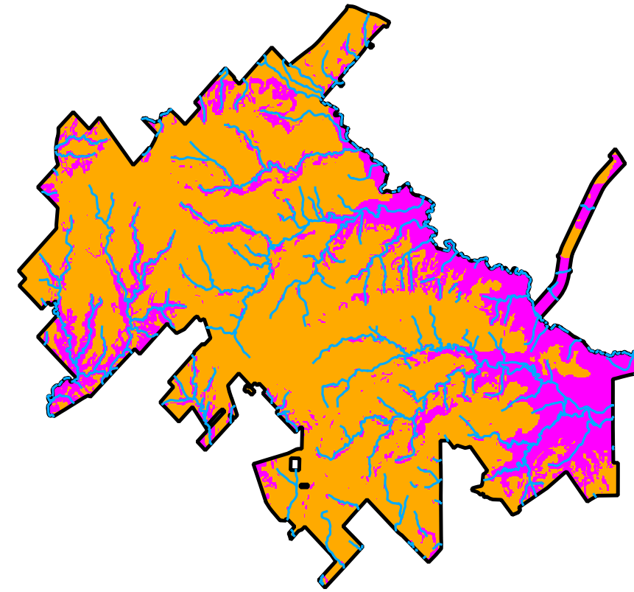
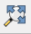
Think about what types of coordinate you want to show on the borders of the map; they have to be the same as used in the Project CRS. Many people like to see the geographic coordinates. For this I often work with the Project CRS as WGS84, and use projection on-the-fly. You may want to be explicit in a caption about what projection you used to conduct any analyses. After setting that, make sure to click the “Zoom Full” button to make sure the focal area takes up as much of the viewing area as possible. (You can also adjust the viewing scale using the “Scale” adjustment at the bottom of the main QGIS screen.)
Once satisfied with the layout of the main map, we are ready to start putting a final layout together.
- Go back to the Composition window.
- In the pane that is on the left, adjust the layout settings through the “Composition” tab.
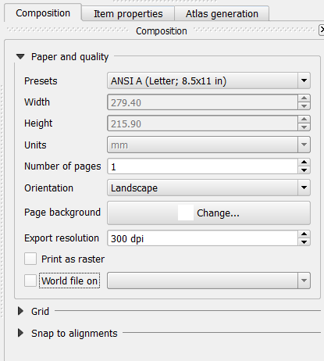
- The only thing we’ll change for now is the Paper Size – change to “ANSI A (Letter; 8.5x11 in).

Putting Everything Together

Adding the Map of interest to the Layout
- In the Composition window click the “Add Map” icon, and click and drag a box for in the area you would like the main map to occupy. The view from the main QGIS window should now appear in that area.
  - You can go to the “Item Properties” tab to adjust the extent and such. I simply click the button “Set to Map Canvas Extent” to show the same extent as in the main QGIS window.
    - By default, the map layout is cached in memory; if you adjust anything in the main map, click the “Update Preview” button to show the updated version.
    - Check the box for “Lock layers for map item”; if you don’t, when you create an inset, this map will be altered.

Adding Gridlines and Coordinates
- In the “Item Properties” tab, check the box and expand the section for “Show grid”. The settings I use are shown in context on the next page and the general appearance is illustrated below.
- The units will be the same as used in the Project CRS. Adjust the spacing and offset in the “Interval” and “Offset” boxes. This usually takes some trial ane error to make it aesthetically pleasing.
- Expand the “Grid frame” section and change “Frame style” to “Zebra”.
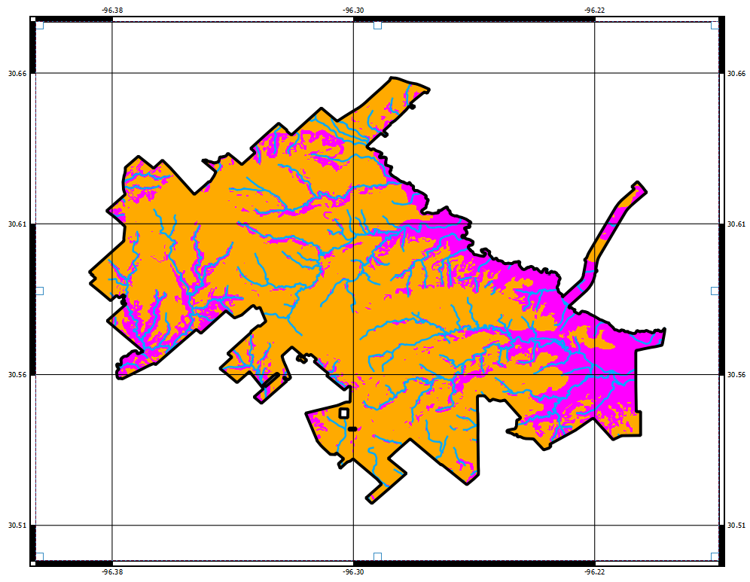
- Expand the “Draw coordinates” section and check the respective box. Adjust settings as you see fit; the only adjustment I illustrate is changing the precision of coordinates shown.

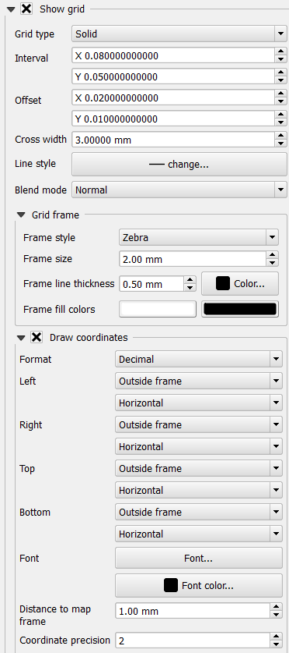

Adding Scale Bar, North Arrow, and Legend
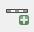
- For the Scale Bar: click the “Add Scale Bar” icon, and click and drag a box where you want the scale bar to be placed.
  - The scale bar will appear in that area with some default settings. You can adjust things like the units and appearance in the “Item Properties’ tab, which now characterizes the scale bar.
*Note: the “Item Properties” tab is dynamic, changing with the type of object you have selected.
- For the North Arrow: click the “Add Image” icon, and click and drag a box where you want the north arrow placed.
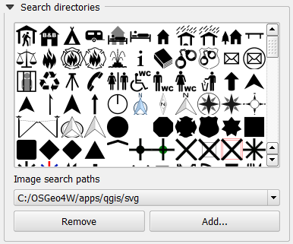
  - In the “Item Properties” tab, expand the section for “Search Directories”. The default path links to a directory that has available images included with QGIS. You will see a few that work as a north arrow; select one and click the “Add” button. You can rotate it if necessary, to match rotation of the map if it is not the typical north-to-the-top orientation.
- For the Legend: Click the “Add new legend” icon, and click and drag a box where you want it to be placed. A default legend will appear in that area; the box will automatically resize to accommodate the dimensions.
  - Again, use the “Item Properties” tab to adjust the settings. Most obviously, we want to change some of the labels in the legend so they are not simply the layer names from our QGIS project. Note that you cannot change the symbology here – you must do that in the main QGIS project window.
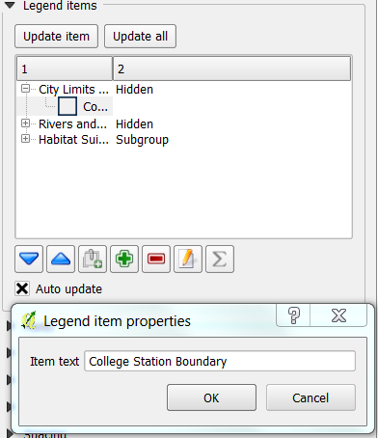
    - Expand the “Legend items” section. You can add a new layer to the legend, re-arrange the order, and rename items. To change the name of an entry, click on the legend entry you wish to edit, and click the “Edit” icon and type a new name that you prefer. In the example shown below, the City Limits entry is being renamed to “College Station Boundary”. For editing specific entries for grouped legend items (e.g., the legend for Habitat Suitability layer), expand the group by clicking the “+” icon next the highest level item, and select the specific item you wish to edit before clicking the “Edit” icon.
    - You can add and edit a box around the legend by clicking the box for, and expanding the “Frame” section.

Adding an Inset
Now, the map is starting to really look like a map, but one thing that is useful to have is an inset that shows where things are in the broader context. To create this, we need to again set up our layers as we wish them to appear in the inset. The only layers we really need here are the County Boundary and the City Limits. It is best to use a copy of the City Limits layer, as it is used on the main map, and editing the original will alter the final product when we export it. To duplicate a layer, in the “Layers” pane of the main QGIS window, select the layer you want a copy of, right click, and click “Duplicate”.
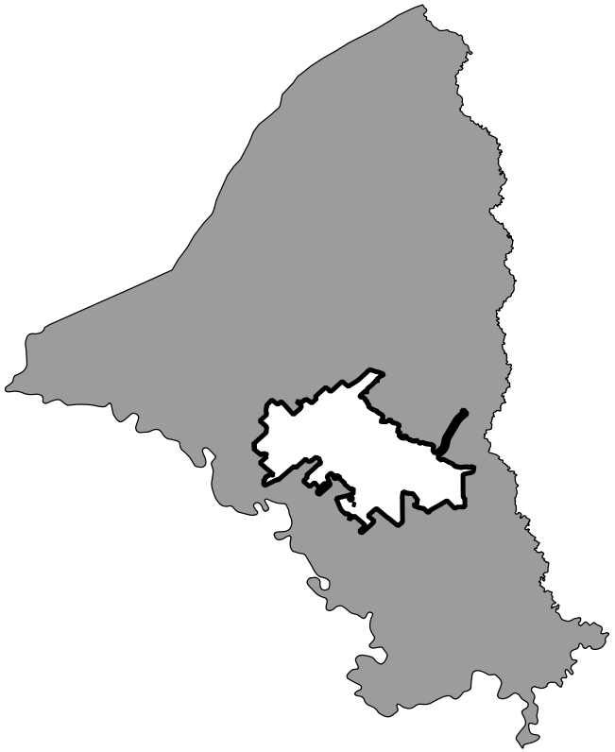
- Do as described earlier to create a suitable looking map with the Brazos County Boundary and City Limits layers in the main QGIS window. Below is an example setup.

- In the Composition window, click the “Add new map” icon again, and draw a box where you want it to appear. You can edit it, as with the main map, using the “Item Properties” tab. Perhaps add a frame to it, to make it stand out and delineate it as a separate entity from the rest of the map. You can also add gridlines and coodinates as desired.
- Again, check the box for “Lock layers formap item”.
- You can add a label to this using the “Add new label” icon; select it and click and drag a box where you would like the text.
  - In the “Item Properties” tab you can edit the text, font characteristics, and text box characteristics.

Final Formatting and Exporting the Map
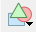
We are almost done creating a final, high quality map. Now you can add anything else you need. On the next page, you can see my final version; the only other element I have added is another label to serve as a title for the map. If you need to move anything around, make sure the “select/move” icon is selected, click on the focal element, and move or re-size it. You can also add shapes and arrows using the “Add ellipse” and “Add arrow” icons.

Exporting the Map
From the Composition window you can export the final product to various image formats, to an SVG file, or to a PDF file. Simply click on the respective icons from the toolbar at top (shown below, in order), designate a file name and location, and click “OK”.
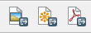
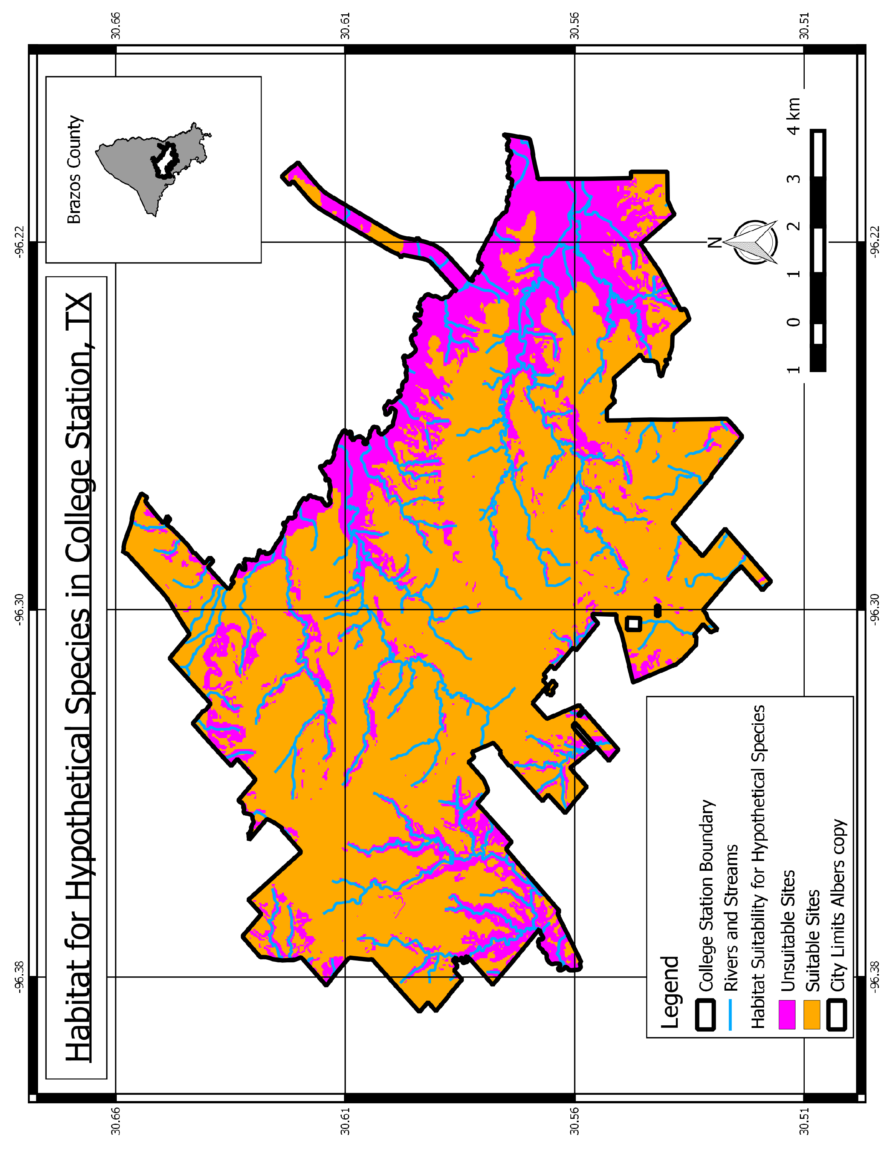

Closing Comments
My goal in this tutorial is to give new users a working knowledge of QGIS. Although we only had time for a handful of operations, I hope that you now have sufficient familiarity with QGIS to explore it further on your own. If you continue expanding your use of QGIS, you may wish to script your work for better reproducibility and documentation. Python is a common language used for scripting in QGIS, and you can find more details on the web (e.g., http://docs.qgis.org/testing/en/docs/pyqgis_developer_cookbook/intro.html).
QGIS is constantly being further developed, and I suggest users periodically check for updates to the software, as new tools are often implemented, and processing and data management protocols are often improved. Since I first started using QGIS, the software has become much more user-friendly, tools have become much more expansive, and bugs have been fixed. Keep up with it, and I think you’ll find it to be a suitable alternative, which is even superior in some ways, to expensive, paid GIS software.

